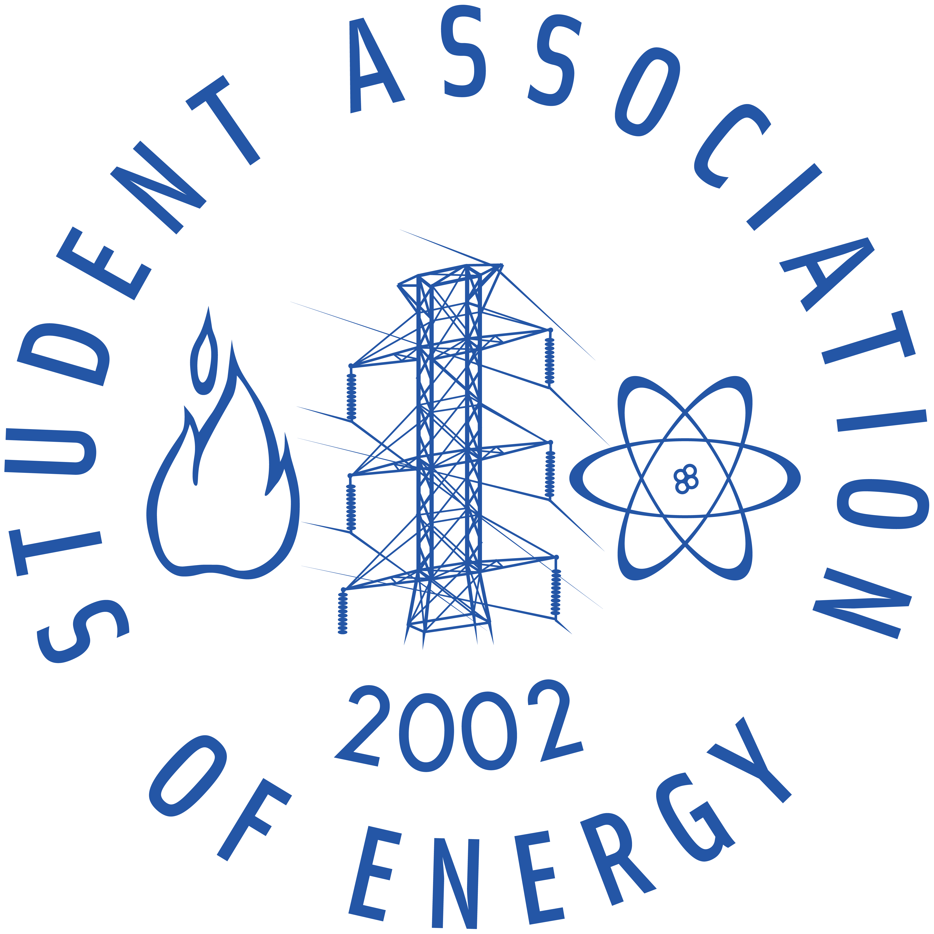
Leó Szilárd on the way to the construction of the first nuclear reactor

The Student Association of Energy's first lecture of the Leó Szilárd Memorial Semester took place on the 16th of February 2012, on the topic of Leó Szilárd’s biography and the improvement of nuclear disciplines. The presentation was held by Csaba Sükösd, associate professor of the Budapest University of Technology and Economics.

Leó Szilárd (February 11, 1898 – May 30, 1964) is one of the greatest scientists in Hungarian and also in world history. Numerous patents, researches, developments belong to his name. He developed a refrigerator with Einstein which has no moving parts, the electromagnetic pump, the cyclotron and the betatron. In 1929 he grounded the basis of information technology with his paper “On the Decrease of Entropy in a Thermodynamic System by the Intervention of Intelligent Beings. He also grounded a new discipline, hot atom chemistry.

Before World War II, a great armaments race started in nuclear sciences too. Szilárd wrote a letter signed by Albert Einstein to the U.S. President about the significance and danger of nuclear energy. He emphasized that the USA has to invent the nuclear bomb first, before Germany. He recognized that a sustainable chain reaction is feasible if a specific amount of fissile material, the so-called critical mass is available. Exactly 70 years ago Leó Szilárd and Enrico Fermi put the first nuclear reactor into operation, which has lead to nuclear power becoming an effective and cheap way to produce energy.

Vivien Lengyel
Member of the Student Association of Energy

